Gasser Dental Corporation
17220 N. Boswell Blvd Suite 200
Sun City, AZ 85373
623-972-8217
www.DrGasser.com
jlittle@drgasser.com

Dear New Patient,
Welcome to the Gasser Dental family. We look forward to serving you. Here are a few things you need to know upon your arrival for your first appointment.
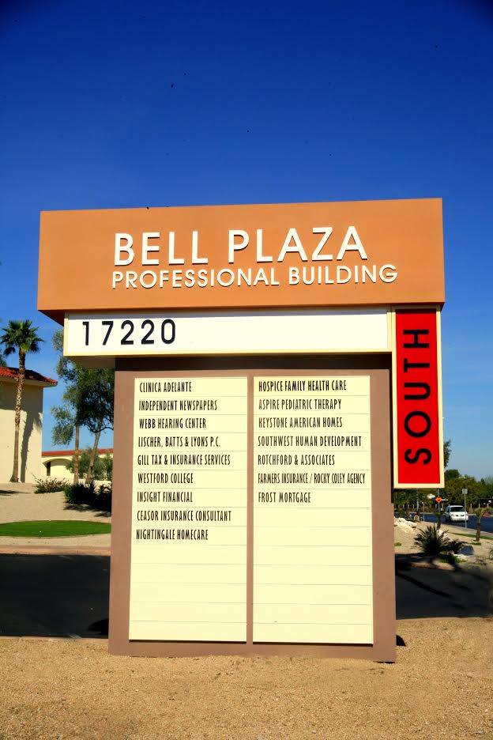
Directions:
Our office is located in the Bell Plaza Professional Building SOUTH on the second level in Suite 200. Provided to the right is a picture of the sign identifying our building.
Below is a map showing the location of Bell Plaza South, found at the crossroads of Boswell Blvd. and Bell Road. Boswell Blvd. is located between N. 99th Avenue and N. Del Webb Blvd.

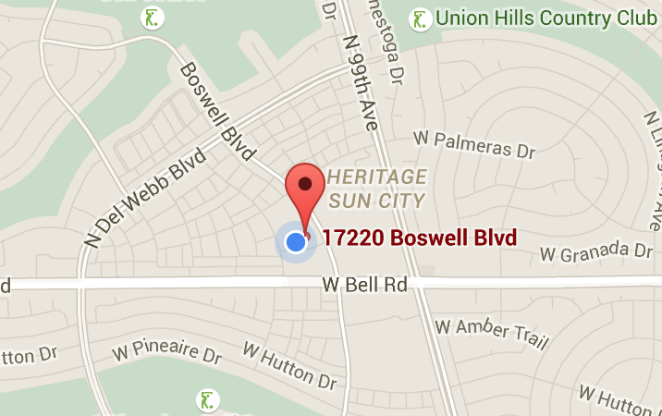

Parking:
Upon arrival, a ‘Visitor’s Parking’ sign will greet you at the entrance, leading you to the designated parking lot for visitors. Pictured below is the front view of the building that you will see when entering the parking lot.
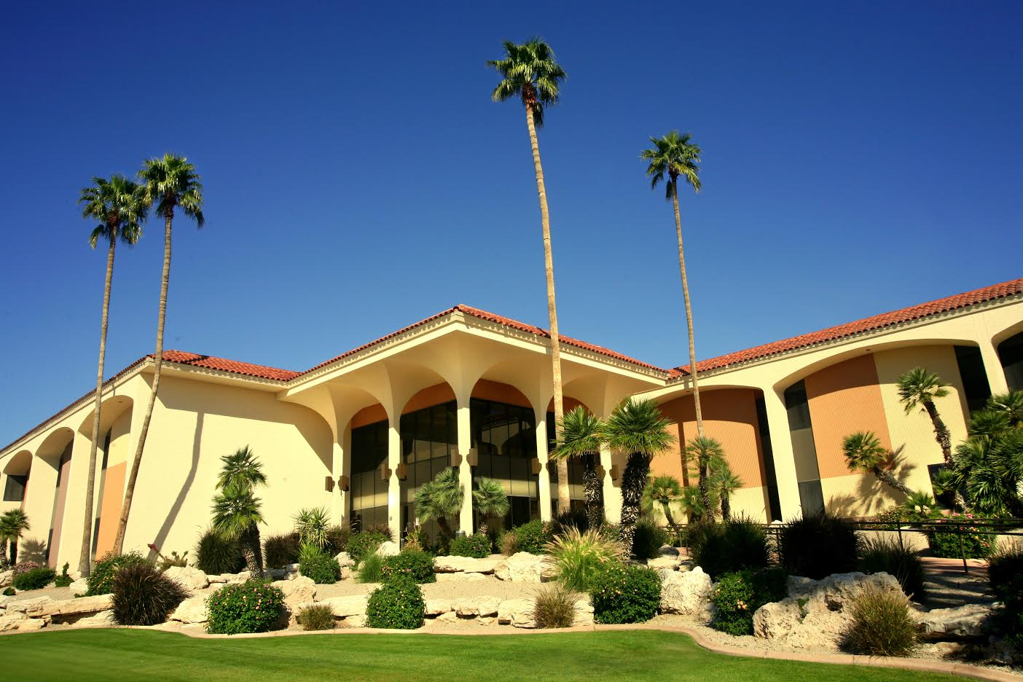

Wheelchair Services:
We offer curbside-wheelchair service in which we will meet you outside of the building and assist you to our office. We have wheelchairs on hand at the office. Please call when you arrive and we will readily meet you.
Reminder Appointment Notice:
As your appointment approaches, we will contact you with a notice regarding the details of your upcoming appointment. We send these notices prior to your scheduled appointment and can do so via e-mail, text, or phone call.
What to expect:
New patients can expect a ‘No Fee Consultation,’ which includes a complete and thorough examination done by Dr. Gasser. This appointment typically lasts an hour. This examination may include a free ICAT dental CT scan (normally valued at $475). It will help determine if a patient is eligible for an implant or additional services. Dr. Gasser provides each patient with a thorough breakdown of all treatment options available and pricing. If you have dental insurance, it is helpful that you bring a copy so that we can incorporate the benefits. If you wish to bring a loved one, whether that be family or friends, we encourage you do to so.

